INSTALLION GUIDELINE ON RESTAUTRANT MANAGEMENT SYSTEM

We have worked on our **Nawab Restaurant Management System**

We developed our software for android operating system. You can install our software in two ways. And so, Installation of Dream super shop (v18.12.004) on android is given below:

# INSTALLATION WAY:

1. First the **wi-fi need** to be on and press **mobile data or Wi-Fi**.
2. **Tap** on **play store** icon.

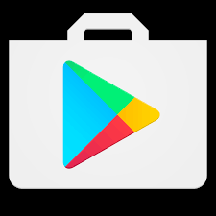

1. *After* that user have to log in with his account with correct user name and password .

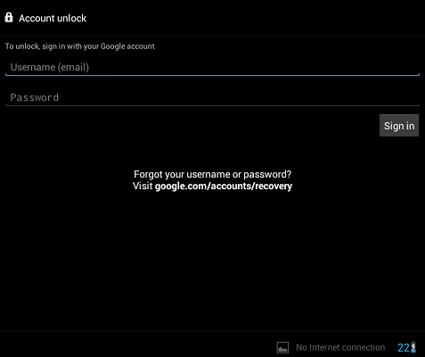

1. Then you have to **log** in your **google account** with correct Gmail address and password. If user have logged in previous with his account then he have don’t need to log in.

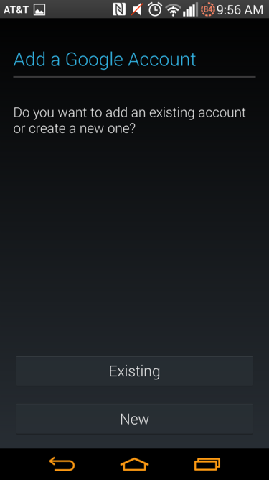

1. After getting entry into play store then user have to click the search button.

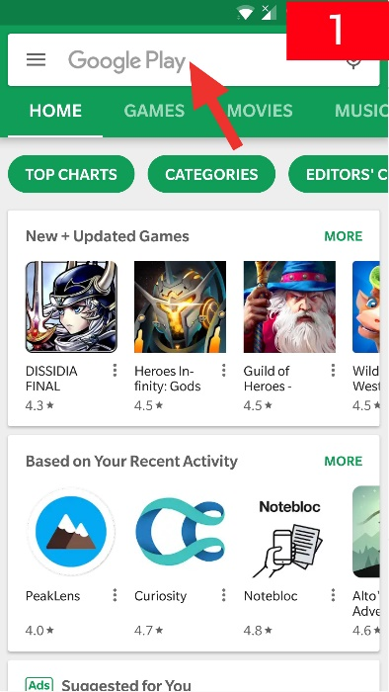

1. After that user have to write the Nawab Restaurant in search box. It will show the software apps, software demo, software demo , review of system.



NAWAB RESTAURANT

Editors choice

Role playing

INSTALL

1. After Searching our software user will show the install button so user have to must press it.
2. After **tapping** on our aps, **some demo picture, others user reviews**.
3. After That ,user have to **tap** on **install button** and then apps will **download** and **install** automatically.
4. All the **data** of our software is saved on **your internal storage**. path would be:

**Android\aaa\nawab.restaurant.com\user**

# ALTERNATIVE INSTALLION WAY.

1. User haveto open the **Settings app** on your Android device**.** IF Android devices cannot install apps from sources other than the Google Play Store (or the Amazon App Store for Kindle devices). To install apps manually, you'll need to allow your device to install apps from other sources.
2. User have to Tap **the Security.** This will open the Security menu.
3. User have to **Scroll down** it **.** Then he have to Tap "OK" to confirm that you want to enable this.
4. After that user have to open a browser,go to **GOOGLE or duck duck go.** And user have to search the name of our app.
5. From theresul**t** of **google search.** User have to download our software Nawab Restaurant management from the other source that \\htttp:nawab restaurant .com\app .So this is the other option for user if user don’t install they have to go to this link.
6. After that user will show the installation option download or he can show the full overview of our system**.**
7. At there, user will find our apps and tap on app**.**.
8. User haveto Tap on **install** and **installation** process will be started.
9. After completing **installation**. **Nawab restaurant** will be found in his phone.
10. All the **data** of our software will be saved in our **storage**. The way will be:

**Android\aaa\nawab.restaurant.com\user**